FERTILIZER SPREADER – DESIGN & DEVELOPMENT
1. Project Overview
Design and development of fertilizer spreader systems for uniform and controlled fertilizer application. The project involved mechanical design, mechanism development, 3D CAD modelling, prototype development, testing, issue resolution and design improvements for production.
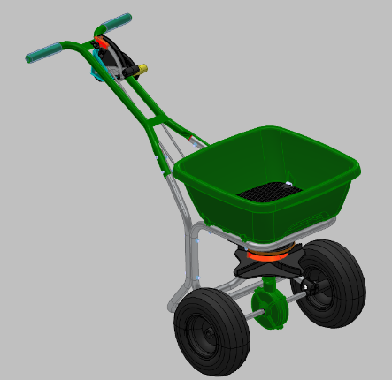 | 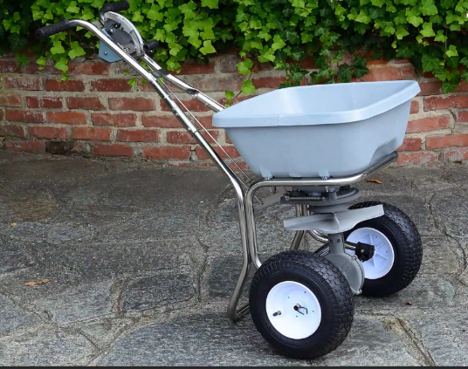 | 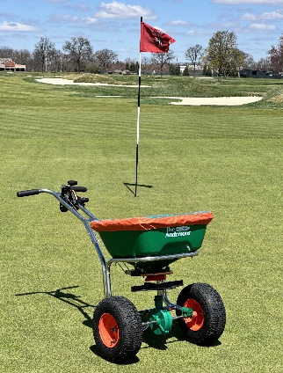
3D Model Design | Prototype | Final Development

2. Key Design & Development Areas
A. Shut-Off Control Mechanism
- Designed and developed the shut-off control mechanism for controlled fertilizer flow.
- Developed linkage between the shut-off control unit and corner mechanism.
- Optimized linkage movement to achieve smooth opening and closing.
- Verified mechanism clearance, movement and fitment during prototype trials.
- Design Plastic components by using surface modelling.
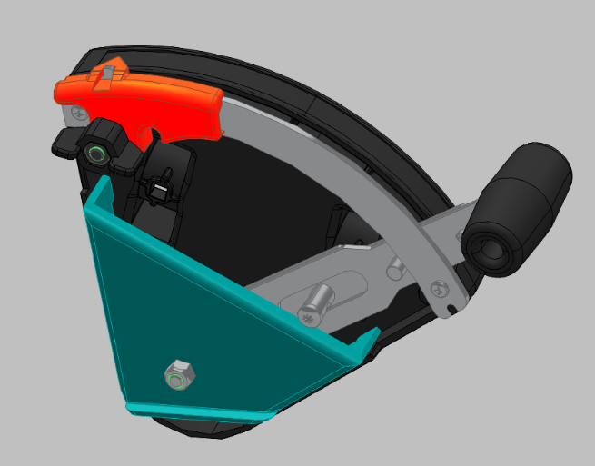

B. Hopper Bottom Control Unit
- Developed the hopper control mechanism for regulating fertilizer discharge.
- Checked component interaction, adjustment range and operating movement.
- Improved mechanism reliability through design modifications and trials.
- Spring Design & Material Selection
- Designed and developed the spring according to the required load, deflection, working stroke, and available installation space.
- Selected suitable spring material based on strength, fatigue life, corrosion resistance, and operating conditions.
- Determined key parameters such as wire diameter, mean coil diameter, number of active coils, free length, and spring rate.
- Performed design calculations and verified the spring for working load, maximum deflection, and allowable stress.
- Conducted prototype testing and functional validation to confirm spring performance under actual operating conditions.
- Optimized the spring design to achieve the required force characteristics, durability, and reliable operation of the fertilizer spreader mechanism.
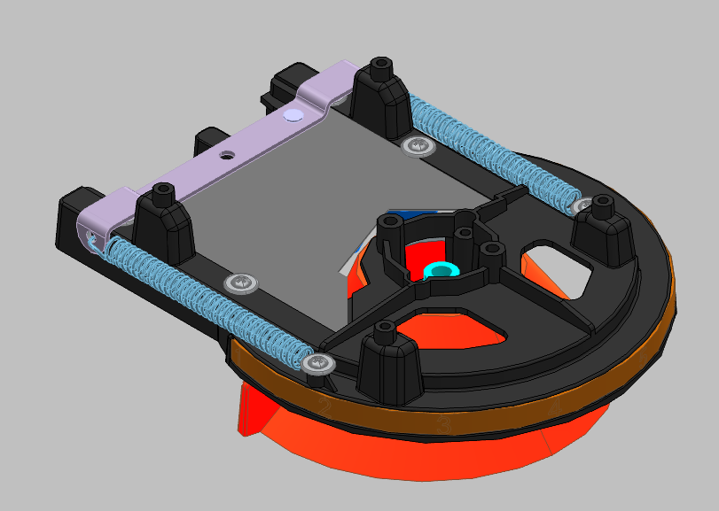

C. Corner Mechanism
- Design & Developed corner mechanism.
- Evaluated hole centre distance, linkage travel and opening/closing movement.
- Optimized the mechanism to accommodate manufacturing and assembly variation.
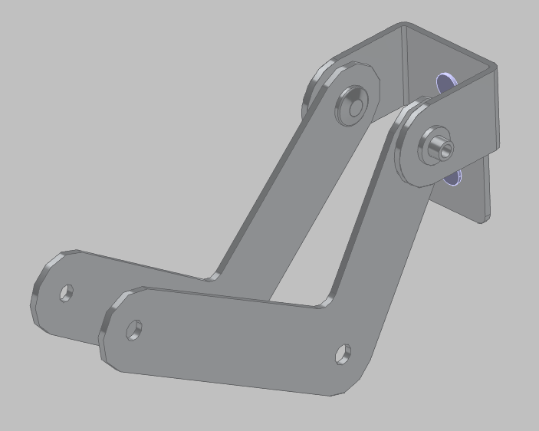

3. Engineering Activities
- 3D CAD modelling and assembly development
- 2D manufacturing drawings
- BOM creation and maintenance
- Design calculations and dimensional validation
- Mechanism and linkage development
- DFM/DFA evaluation
- Prototype development
- Tool and mould development support
- T0/T1 trial evaluation
- ECN implementation
- Supplier coordination
- Part inspection and fitment validation
- Functional testing
- Root-cause investigation
- Design optimization
- Production support
4. Problem-Solving Approach
Problem Identification → Root Cause Analysis → Concept Development → CAD Modification → Prototype/Trial → Testing → ECN → Validation → Production Release
5. Software & Engineering Tools
- Solid Edge / NX – 3D modelling and drafting
- MSC Adams – Dynamic mechanism simulation
- Excel – BOM, design data and analysis
- Odoo – Engineering/BOM data management
6. Key Project Deliverables
- 3D models
- 2D manufacturing drawings
- Assembly drawings
- BOMs
- ECN revisions
- Prototype parts
- Trial reports
- Design validation
- Supplier/tooling coordination
- Production-ready components
7. Engineering Impact
The development activities focused on improving:
- Fertilizer application control
- Mechanism reliability
- Component durability
- Ease of operation
- Assembly and manufacturability
- Adjustment accuracy
- Product quality
- Production readiness
8. Project Outcome
The developed mechanism provides a mechanically controlled shut-off system for the fertilizer spreader, with the corner linkage transferring operator input to the hopper outlet mechanism.

